**Demo – How to add faceting**

I want to import documents from a directory and use the directory name as a facet field. This will then enable me to group search results using a facet that corresponds to the original source directory they were imported from.  
  
I have a top-level directory structure like this:  
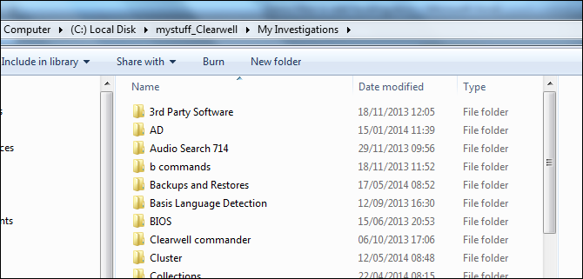  
  
I plan to perform separate imports for each of these sub-directories, like this:  
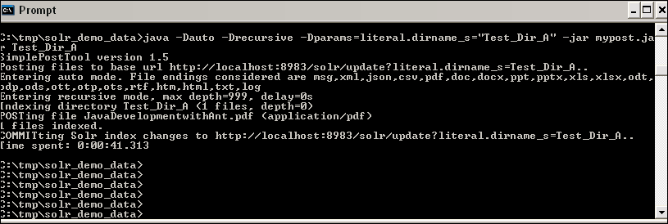  
  
**Note**: Using a field name with a trailing “_s” like this should result in the field “dirname_s“ being automatically created in Solr without the need to define the field in the core’s schema.xml file.  
  
If we import some test data like this, we should then be able to see the presence of this new field in the search results:  
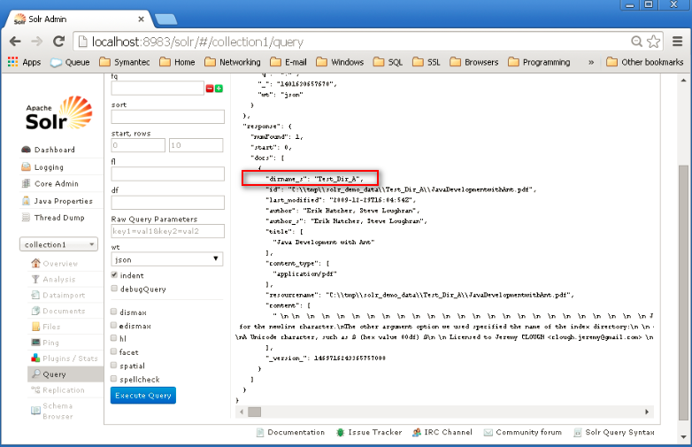

Good so far. But, if we switch to the Solritas demo view we still see the default fields being used for the facets:  
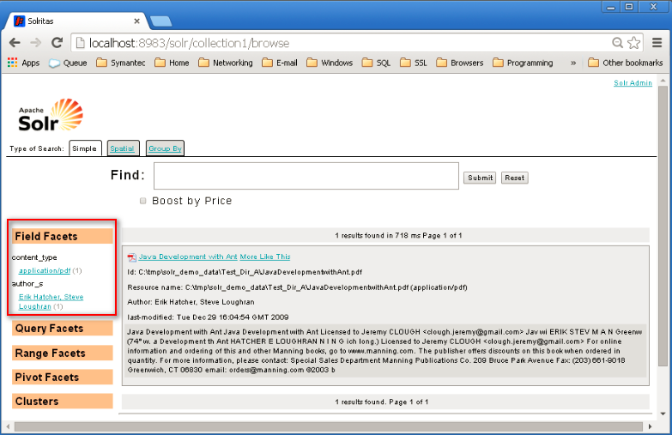  
  
To utilise our new “dirname_s” field as a facet field, we have to edit the core’s solrconfig.xml:  
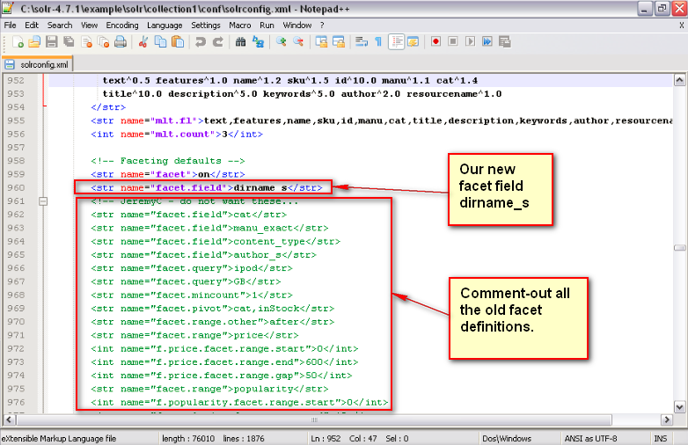  
  
If we reload the page we will now see just our new “dirname_s” facet:  
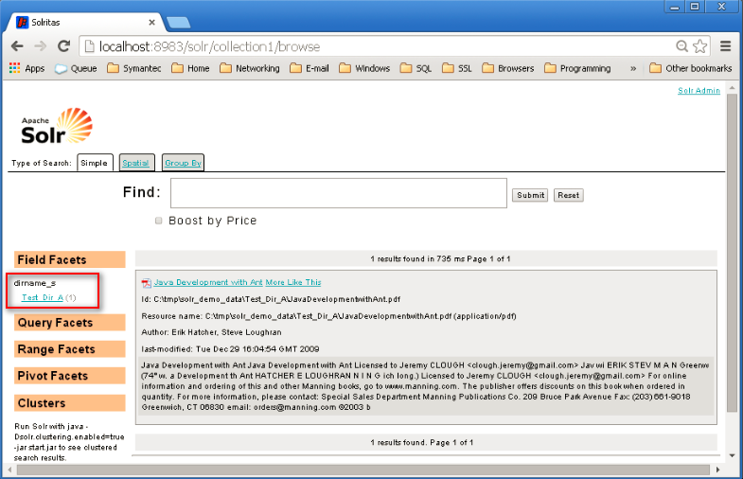  
It’s that simple. No other changes were needed!  
  
**Note**: By default, the Solr demo both indexes and stores the field values. It makes sense to reduce the index size by not storing the document contents. To do this, make the following change in the core’s schema.xml file:  
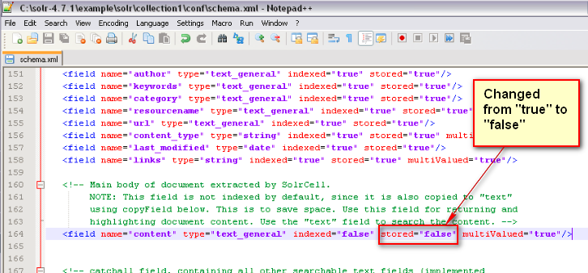

The UI now no longer shows the document contents:  
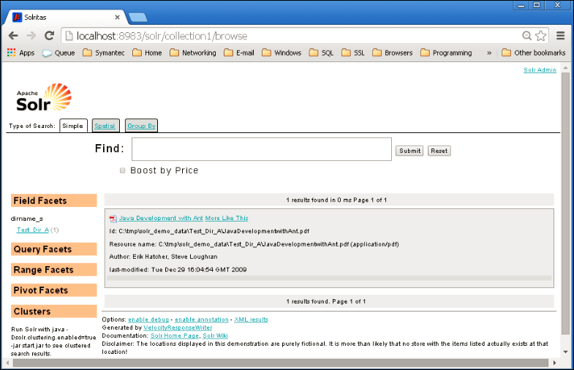  
  
**END**